Module 2

ASSIGNMENT NAME: adding new pages

SITE URL

<http://patel3.centralus.cloudapp.azure.com/module3/index.php>

GIT HUB REPOSITORY

<https://github.com/shyam13/myProject>

DESKTOP SCREENSHOT

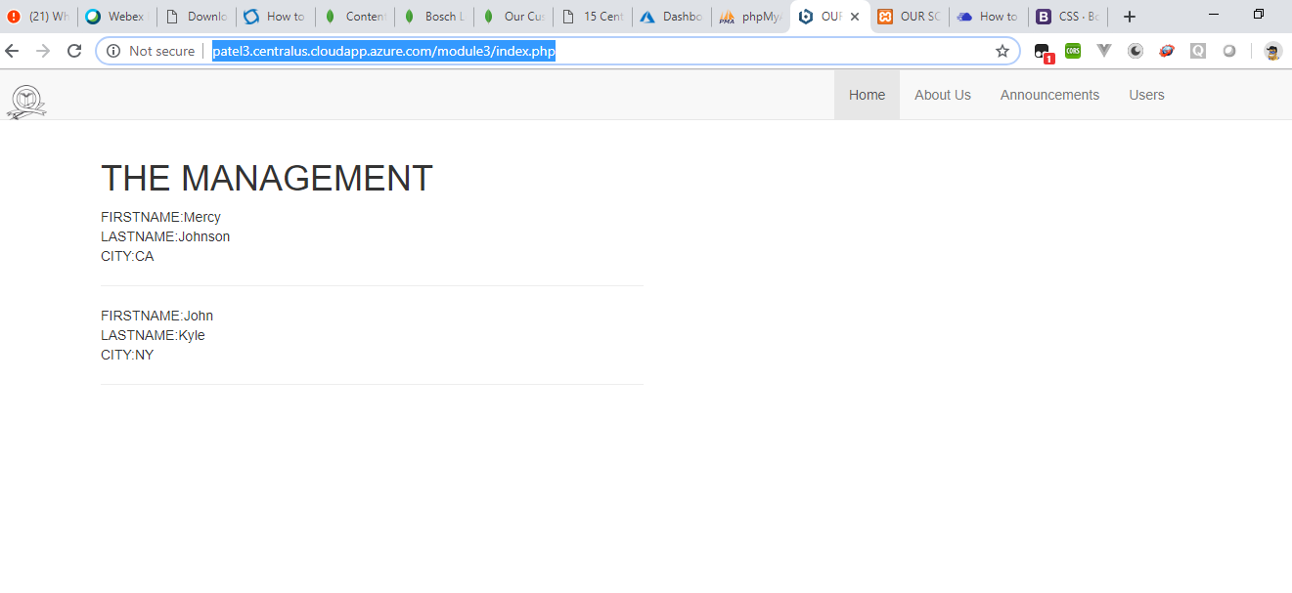

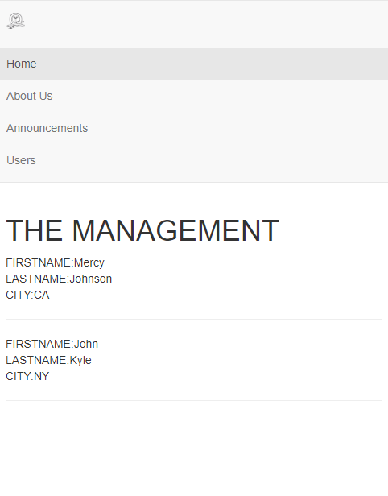

MOBILE PHONE SCREENSHOT

